## **ZELLBURY**

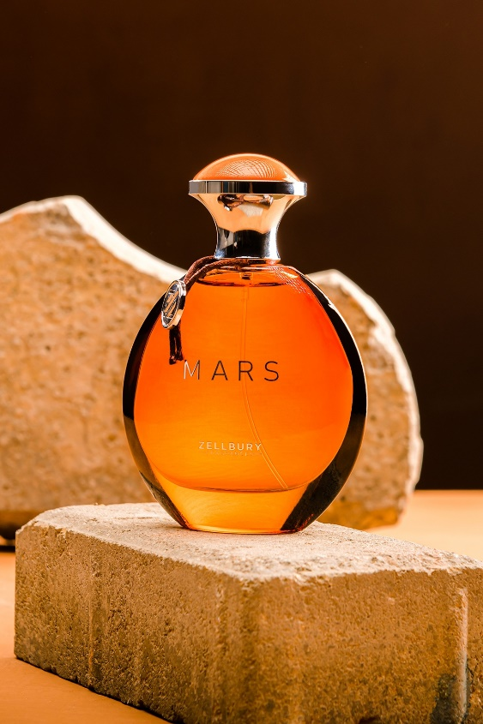

**Mars Perfume**

**Reviews**

**PKR 4,890.00**

**A bold fusion giving you the ultimate scent to get noticed in. MARS allows you to be bold and enigmatic all year around. MARS is fashioned to stand the test of time.  
Hurry only 34 left, 11 sold since yesterday Get delivery estimates**

**Size: 100ml Bottle**